Cloud Foundry 1

Key Features: 1

Architecture 2

BuildPacks 2

Kubernetes vs Cloud Foundry: 4

Deployment in Cloud foundry 8

Orgs & Spaces 9

Guids 9

Manifests 9

Scaling 10

Cloud Foundry is an open-source, platform-as-a-service (PaaS) solution that allows developers to build, deploy, and scale applications without worrying about the underlying infrastructure. It is particularly designed for cloud-native applications and supports multiple programming languages, frameworks, and services. Here’s a deeper look at Cloud Foundry:

### Key Features:

* **Multi-Language Support**: Cloud Foundry supports a wide range of programming languages like Java, Node.js, Python, Ruby, Go, and PHP, enabling developers to deploy a variety of applications.
* **Infrastructure Independence**: Cloud Foundry can run on multiple cloud environments such as AWS, Google Cloud, Microsoft Azure, and on-premises infrastructures using IaaS platforms like OpenStack and VMware. This gives developers flexibility in choosing their deployment environment.
* **Containers and Orchestration**: Cloud Foundry uses containers (using technologies like Garden for its containerization) to run applications in isolated environments. This ensures efficient resource usage and secure operations.
* **Application Lifecycle Management**: The platform offers continuous delivery tools that allow applications to be developed, tested, and deployed rapidly and reliably. Its support for CI/CD pipelines helps streamline the deployment process.
* **Service Integration**: Cloud Foundry provides a marketplace for services, allowing developers to easily integrate databases, messaging systems, and other third-party services into their applications. Users can bind services to applications without managing infrastructure directly.
* **Self-Healing and Auto-Scaling**: The platform monitors application health and automatically restarts instances if failures occur. It also provides auto-scaling features, adjusting resources dynamically based on demand.
* **Buildpacks**: A key component of Cloud Foundry, buildpacks automate application dependency management by detecting the app’s language and framework, compiling it, and ensuring it’s ready for deployment.
* **Zero Downtime Deployment**: Cloud Foundry ensures smooth, zero-downtime updates and rollbacks for applications by routing traffic only to healthy instances during updates.

Architecture**:**

* **Cloud Controller**: Manages the lifecycle of applications, including deployment and scaling.
* **Diego**: A scheduler and container manager that handles the distribution of application containers across VMs.
* **Router**: Routes external traffic to the appropriate application instance.
* **Loggregator**: Provides logging and metrics for applications.
* **BOSH**: A tool used to deploy and manage Cloud Foundry itself, often referred to as the “director” that ensures the platform remains healthy and operational.

**Advantages:**

* **Developer Productivity**: By abstracting away infrastructure management, developers can focus solely on writing and improving their applications.
* **Open Source**: As an open-source project, Cloud Foundry benefits from a large community of contributors and constant innovation.
* **Flexibility**: Cloud Foundry’s platform-agnostic design means it can be deployed on private clouds, public clouds, or hybrid environments, making it highly adaptable to various organizational needs.

Cloud Foundry is a key player in the cloud-native ecosystem, offering organizations a way to accelerate their cloud adoption while maintaining flexibility and operational control over their applications.

## BuildPacks

Build packs in Cloud Foundry help make your app work in the cloud by figuring out what it needs to run. For example, if you build an app using Java or Python, the buildpack checks what language and tools (like libraries or frameworks) your app needs. It then automatically gathers everything, compiles your code, and makes sure it’s ready to launch. Basically, it does the hard work of setting up the environment for your app, so you don’t have to manually install anything.

**Deep Dive:** Buildpacks are an essential mechanism in Cloud Foundry that abstract away the complexity of managing application dependencies. Here’s how they work in more detail:

* **What Buildpacks Do**: When you push an app to Cloud Foundry, the platform doesn’t just run your code as-is. It needs to know how to set up the right environment for the application to run correctly. This includes installing necessary runtimes (like Java Virtual Machine for Java apps or Python interpreter for Python apps), libraries, frameworks, and other dependencies. Buildpacks automate this entire process.
* **Detection Process**: When an app is uploaded, Cloud Foundry uses the buildpack’s “detection script” to figure out which programming language or framework the app is written in. For instance, it may check for files like package.json for Node.js apps or pom.xml for Java apps. This helps it identify what language and tools the app requires.
* **Compilation and Dependency Management**After detecting the app’s language, the buildpack compiles the source code into an executable format. During this step, it installs the necessary runtime, libraries, and any dependencies that are specified by the developer. For example, if you’re deploying a Java app, the buildpack ensures the appropriate Java version is installed, fetches libraries, and sets up the Java environment to run the app.
* **Example**: For a Node.js app, the Node.js buildpack will:
  + Install the right version of Node.js based on your configuration.
  + Download all required npm packages (from package.json).
  + Optimize the app for cloud deployment, such as setting environment variables.
* **Multiple Buildpacks**: Cloud Foundry supports using multiple buildpacks on a single app. For example, an app might need both a Ruby runtime and a database setup. The buildpack framework allows for stacking different buildpacks, enabling an app to have all the necessary environments configured for it to run smoothly.
* **Customization and User-defined Buildpacks**: Cloud Foundry has a set of standard, pre-configured buildpacks (for languages like Java, Node.js, Go, Python, Ruby, etc.), but users can also create custom buildpacks. This is especially useful for organizations that need specialized tools or libraries that aren’t included in the default buildpacks.
* **Role in Continuous Delivery**: In a continuous delivery pipeline, buildpacks allow for quick and automated deployments. Since the buildpack takes care of compiling, installing dependencies, and optimizing the app’s runtime environment, developers can continuously push new versions of their app to Cloud Foundry without needing to manually configure environments each time.
* **How Buildpacks Ensure Portability**: Buildpacks also help maintain portability across environments. Whether you’re deploying to a private cloud, public cloud, or hybrid environment, the same buildpack will ensure that the application gets the necessary setup to run. This abstraction layer allows developers to focus on coding, while buildpacks handle the environment setup in the background.
* **Container Compatibility**: Once the app is packaged with the necessary environment through buildpacks, it is typically placed inside a container (like a **Garden** container in Cloud Foundry). This ensures the app runs in an isolated and consistent environment. Buildpacks thus play a vital role in getting apps “container-ready.”

**Summary:**

* **Without Buildpacks**: Developers would have to manually install all dependencies, set up environments, and ensure their code can run in the target environment.
* **With Buildpacks**: Cloud Foundry automatically detects the app’s needs, sets up everything, and compiles the app for you. This simplifies the deployment process and speeds up delivery, especially in large-scale, cloud-native environments.

## Kubernetes vs Cloud Foundry:

Kubernetes (K8s) and Cloud Foundry (CF) are both platforms for deploying and managing applications, but they have different approaches, ecosystems, and levels of abstraction. Below is a comparison of Kubernetes and Cloud Foundry across various dimensions:

**1. Primary Focus**

* **Kubernetes**:
  + **Container Orchestration**: Kubernetes is primarily a **container orchestration platform**. It focuses on managing containers (typically Docker containers) across a cluster of machines. Kubernetes automates tasks like container scheduling, scaling, and network configuration.
  + **Infrastructure-focused**: Kubernetes gives developers and operators more control over infrastructure and application details.
* **Cloud Foundry**:
  + **Platform as a Service (PaaS)**: Cloud Foundry is more of a **PaaS** that abstracts infrastructure concerns and focuses on the **application** itself. It simplifies the deployment process for developers by automatically handling dependencies, build processes, and networking.
  + **Application-focused**: Developers don’t have to worry much about the underlying infrastructure or container management; they just push their application code.

**2. Deployment Model**

* **Kubernetes**: You need to provide a **container image** (such as Docker) and define **YAML configuration files** (like Deployments, Services, etc.) to manage how your application runs, scales, and communicates.
  + It requires users to have knowledge of containers and the underlying infrastructure.
* **Cloud Foundry**:
  + Applications can be deployed directly from source code using **buildpacks**. The platform takes care of containerizing your application based on the detected language and framework.
  + The configuration is simpler (using manifest.yml), and developers don’t need to manage container images or write complex configuration files for deployments.

**3. Abstraction Level**

* **Kubernetes**:
* **Lower-level Abstraction**: Kubernetes provides low-level infrastructure primitives (e.g., Pods, Services, ConfigMaps, Persistent Volumes). It requires more involvement in container lifecycle management and networking configurations.
* Developers often interact with Pods, ReplicaSets, and other Kubernetes-specific resources.
* **Cloud Foundry**:
  + **Higher-level Abstraction**: CF hides infrastructure complexity and offers a developer-centric experience. Developers interact with higher-level abstractions like applications, routes, and services without needing to worry about containers or VMs.

**4. Application Packaging**

* **Kubernetes**:
  + Applications are packaged as **container images** (typically Docker images).
  + Requires a **Dockerfile** or pre-built images. The developer must handle containerization themselves or use CI/CD pipelines to build images.
* **Cloud Foundry**:
  + Applications can be pushed directly as **source code**. Cloud Foundry uses **buildpacks** to detect the app’s language and framework, and automatically handles the build process, packaging the app into a container behind the scenes.
  + No need to create Docker images manually; CF takes care of this.

**5. Scaling and Resource Management**

* **Kubernetes**:
  + **Explicit Scaling**: Scaling in Kubernetes is managed explicitly through the configuration of Pods and ReplicaSets. Horizontal scaling requires configuring auto-scaling policies based on CPU, memory usage, or custom metrics.
  + You have fine-grained control over resource requests and limits for containers.
* **Cloud Foundry**:
  + **Automatic Scaling**: CF allows simple scaling by specifying the number of app instances in the manifest.yml. Developers can scale horizontally without thinking about Pods or containers.
  + Resources like memory and disk space are specified per app instance but without granular control over containers.

**6. Service Binding**

* **Kubernetes**: Kubernetes offers a **Service** resource to expose applications within or outside the cluster. Integrating external services (e.g., databases, message queues) typically requires additional setup, often through Kubernetes Operators or Helm charts.
* **Cloud Foundry**: CF has an integrated **Service Marketplace** where developers can bind external services (like databases, message brokers) to applications with minimal configuration. The cf bind-service command handles service binding, credential management, and injection into the app’s environment.

**7. Networking**

* **Kubernetes**: Kubernetes requires you to configure networking manually. Pods communicate via virtual networking, and you need to set up Services, Ingress controllers, and sometimes custom networking plugins (e.g., Calico, Flannel) to manage inter-Pod communication and external access.
* **Cloud Foundry**: CF automatically creates **routes** and handles networking for applications. Routes are generated or manually assigned through cf push. You don’t need to configure load balancers or services manually.

**8. Ease of Use**

* **Kubernetes**: **Complex Setup**: Kubernetes has a steeper learning curve and requires a more complex setup for deploying and managing applications. Operators must be familiar with container orchestration, infrastructure management, and YAML configuration files.
* **Cloud Foundry**: **Developer-Friendly**: CF is easier for developers to use because of its higher abstraction level. It has a simple command-line interface (cf push) and abstracts infrastructure details, making it faster to deploy applications

|  |  |  |
| --- | --- | --- |
| Feature | Cloud Foundry (CF) | Kubernetes (K8s) |
| Focus | Container orchestration | Application-centric platform (PaaS) |
| Abstraction Level | Low-level control over infrastructure | High-level abstraction of infrastructure |
| Application Packaging | Requires container images | Push source code (buildpacks) |
| Scaling | Explicit (manual or auto-scaling policies) | Simplified scaling (instances) |
| Service Integration | Manual (services, operators) | Integrated service marketplace |
| Networking | Complex (services, ingress, virtual nets) | Automatically managed routes |
| Ease of Use | Steep learning curve | Developer-friendly, simpler interface |
| Vendor Lock-in | Less lock-in (more flexibility) | Potential vendor lock-in with managed CF |
| Deployment Configuration | Defined in manifest. yml | Defined in deployment. yaml and service. yaml |
| Container Image | Not required (buildpack handles it) | Required (pre-built Docker image must be specified) |
| Scaling | instances: 2 (managed by CF) | replicas: 2 (managed by K8s  Deployment) |
| Memory/Resource Limits | memory: 512M, disk_quota: 1024M (simple) | Explicit resources with CPU and memory requests/limits |
| Environment Variables | Defined in manifest. yml under env | Defined in deployment. yaml under env |
| Port Configuration | Port automatically managed by CF (buildpack defaults) | Explicit port mapping (containerPort:  8080) |
| Route/Load Balancer | Automatically generated (route in manifest. yml) | Defined using a Service (LoadBalancer) |
| Image Management | Handled automatically via buildpacks | Pre-built image pushed to registry |
| Platform Responsibility | Handles much of the infrastructure for you (PaaS) | Requires more manual configuration (CaaS) |

* cf help displays help for the most frequently used commands
* cf help -a display help for all available commands.
* cf <command> -h (or --help) displays the detailed help for executing a particular command.
* You can set the API endpoint either with the cf api
  + cf api <API_ENDPOINT>
* cf login  interactively authenticate
* If you run cf target, you will see that you are authenticated. You can then log out using:
  + cf logout

Deployment in Cloud foundry:

* You deploy apps to Cloud Foundry with the cf push command.
* Initially you’ve to change to the local directory of the application.
* There should be a manfiest.yml file.

Let’s look at the directives in the manifest.yml:

* name: first-push - The name of the application in Cloud Foundry. The name should be a descriptive name for use by humans and can be anything you want.
* instances: 1 - The number of instances of the application Cloud Foundry should create.
* memory: 32M The amount of memory allocated to the container for each application instance.
* disk_quota: 64M - The amount of disk allocated to the container for each application instance.
* random-route: true - Specifies that Cloud Foundry should generate a random route for accessing the app.
* buildpacks: - The buildpack(s) used to containerize your application.
  + staticfile_buildpack - In this case, we only need the staticfile buildpack.

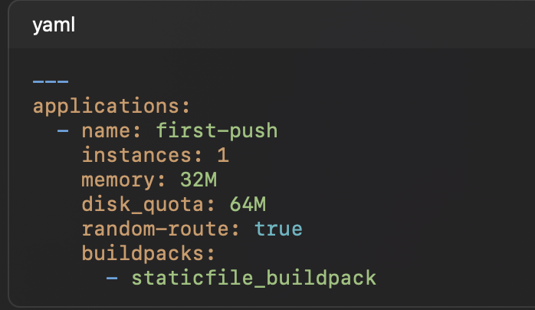

* If everything is successful, you should see output for your running application similar to:

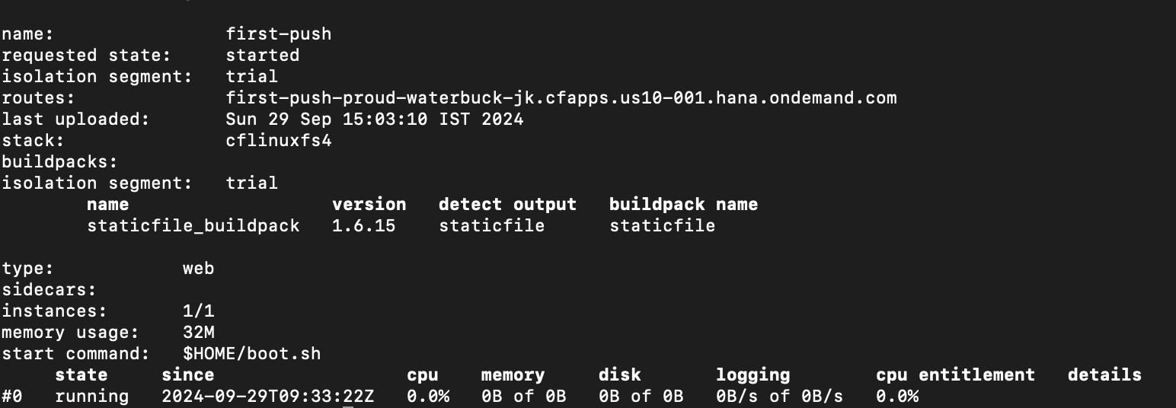

## Orgs & Spaces

* Organizations (orgs) and spaces are logical separations within a Cloud Foundry instance.
* Spaces live within orgs, and a single org can contain one or more spaces.
* Orgs are often used to separate tenants or projects. Within an org you might have separate spaces for different lifecycle stages, like development, staging, and production.
* You can change the org and space you are using by:
  + cf target -o <THE_ORG> -s <THE_SPACE>
* Applications are always deployed to a space, and a space is always scoped to an org
* Because apps are scoped to a space, app names need to be unique in that space

## Guids

* Along with resource names, objects created in Cloud Foundry are assigned a globally unique identifier (GUID).
* Like resource names, an object’s GUID will sometimes be passed to CLI commands. Unlike resource names, guids are globally unique.
  + cf app first-push --guid

## Manifests

* Cloud Foundry can create a manifest for you based on the current state of a deployed application
  + cf create-app-manifest <app-name>
* It’ll be downloaded under your current directory ass <app_name>_manifest.yml, not manfiest.yml, as it’s named after the app.
* To use this manifest on a push, you need to supply the -f flag and the path to the manifest (or rename the file to manifest.yml, which is the default that the CLI will look for in the current directory).
* We can send the parameter during the push command
  + cf push -f static-app_manifest.yml -p app.zip --var instances=1
* It is good practice to define a vars file for each environment (development, staging, prod, etc) rather than relying on variables on the command line.
  + We could therefore define a file <app-name>_dev.yml:
    - instances: 1 (as data in file)
    - cf push -f static-app_manifest.yml -p app.zip --vars-file=static-app_dev.yml

## Scaling

* Horizontal Scaling:
  + cf scale -i 2 <app-name>
* Vertical Scaling
  + cf scale -m 48M -k 256M <app-name>
  + Scaling vertically involves downtime as the containers are recreated with different resource allocations